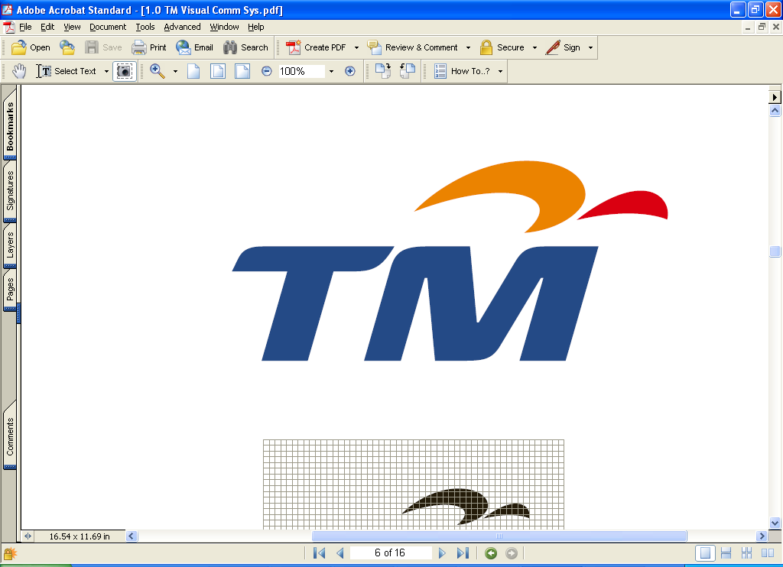

TELEKOM MALAYSIA BERHAD

(Company No. 128740-P)
(Incorporated in Malaysia under the Companies Act, 1965)

NOTICE OF EXTRAORDINARY GENERAL MEETING

NOTICE IS HEREBY GIVEN that our Extraordinary General Meeting (“EGM”) will be held at Dewan Merdeka, Level 4, Putra World Trade Centre, 41 Jalan Tun Ismail, 50480 Kuala Lumpur on Tuesday, 17 May 2005 at 11.00 a.m. or immediately after the conclusion of our 20th Annual General Meeting (“AGM”), whichever is later, or at any adjournment thereof. The AGM will be held at the same venue and on the same day at 10.00 a.m. or at any adjournment thereof. The EGM will be held for the purpose of considering and, if thought fit, passing with or without modifications, the following resolutions:

ORDINARY resolution 1
CALL AND PUT OPTION WHICH REQUIRES OR ENTITLES THE ACQUISITION BY TM INTERNATIONAL (L) LIMITED (“TMIL”), OUR WHOLLY OWNED SUBSIDIARY, OF UP TO AN ADDITIONAL 52.7% EQUITY INTEREST IN PT EXCELCOMINDO PRATAMA (“EXCELCOMINDO”), COMPRISING UP TO 1,193,656 EXCELCOMINDO SHARES (“OPTION SHARES”), FOR A CASH CONSIDERATION OF UP TO USD606.1 MILLION (APPROXIMATELY RM2,303.2 MILLION) (“CALL AND PUT OPTION”)

THAT, approval be and is hereby given for the acquisition by TMIL of the Option Shares, for a cash consideration of up to USD606.1 million (approximately RM2,303.2 million) upon the terms and conditions set out in the Call and Put Option Agreement dated 11 January 2005 between TMIL and PT Telekomindo Primabhakti;

THAT our Board of Directors be authorised to assent to any conditions, variations, modifications and/or amendment as may be required by any relevant authorities or as may be in the interest of TMIL to give effect to the Call and Put Option;

THAT our Board of Directors be authorised to enter into all other agreements, documents and arrangements with any party or parties and to take any or all other actions as they may deem necessary, appropriate and desirable to submit all relevant applications to the relevant authorities for the purpose of the Call and Put Option;

AND THAT our Board of Directors be and are authorised to do all such acts, deeds and things as are necessary and/or expedient to implement, finalise, complete and give full effect to the Call and Put Option.

ORDINARY resolution 2
Proposed LISTING of mtn networks (PRIVATE) LIMITED (“MTN NETWORKS”), our WHOLLY OWNED subsidiary, on THE colombo stock exchange (“PROPOSED LISTING OF MTN NETWORKS”)

THAT, subject to the approvals of the relevant authorities, the proposed listing of MTN Networks on the Colombo Stock Exchange, details of which are set out in Section 3.1 of the Circular to Shareholders dated 25 April 2005, copies of which have been circulated to the shareholders, be approved and adopted;

THAT our Board of Directors be authorised to assent to any conditions, variations, modifications and/or amendment as may be required by any relevant authorities to give effect to the Proposed Listing of MTN Networks;

THAT our Board of Directors be authorised to enter into all other agreements, documents and arrangements with any party or parties and to take any or all other actions as they may deem necessary, appropriate and desirable to submit all relevant applications to the relevant authorities for the purpose of the Proposed Listing of MTN Networks;

AND THAT our Board of Directors be and are authorised to do all such acts, deeds and things as are necessary and/or expedient to implement, finalise, complete and give full effect to the Proposed Listing of MTN Networks.

ORDINARY RESOLUTION 3
Proposed amendments to the existing Bye-Laws governing our employees’ share option scheme (“PROPOSED BYE-LAWS AMENDMENTS”)

THAT, the proposed amendments to the existing Bye-Laws of our employees’ share option scheme in the form and manner as set out in Appendix IV of the Circular to Shareholders dated 25 April 2005, copies of which have been circulated to the shareholders, be approved and adopted;

AND THAT our Board of Directors be and are authorised to do all such acts, deeds and things as are necessary and/or expedient in order to give full effect to the Proposed Bye-Laws Amendments with full powers to assent to any conditions, modifications and/or amendments as may be required by any relevant authorities.

ORDINARY RESOLUTION 4
Proposed GRANT OF OPTIONS TO YBHG DATO’ ABDUL WAHID OMAR (“PROPOSED GRANT OF OPTIONS”)

THAT, subject to the passing of Ordinary Resolution 3 and the approvals of relevant authorities, our Board of Directors be authorised at any time and from time to time to offer and to grant to YBhg Dato’ Abdul Wahid Omar, our Group Chief Executive Officer, options pursuant to our employees’ share option scheme (“ESOS”) to subscribe for up to 1,200,000 ordinary shares in Telekom Malaysia Berhad subject to the provisions of the Bye-Laws of our ESOS.

SPECIAL RESOLUTION 1
Proposed amendments to our articles of association (“PROPOSED ARTICLES AMENDMENTS”)

THAT, the proposed amendments to our Articles of Association in the form and manner as set out in Appendix VI of the Circular to Shareholders dated 25 April 2005, copies of which have been circulated to the shareholders, be approved and adopted;

AND THAT our Board of Directors be and are authorised to do all such acts, deeds and things as are necessary and/or expedient in order to give full effect to the Proposed Articles Amendments with full powers to assent to any conditions, modifications and/or amendments as may be required by any relevant authorities.

BY ORDER OF THE BOARD

Wang Cheng Yong (MAICSA 0777702)
Zaiton Ahmad (MAICSA 7011681)
Secretaries

Kuala Lumpur, Malaysia
25 April 2005

Notes:

- A member entitled to attend and vote at the above Meeting is entitled to appoint a proxy to attend and vote in his stead. A proxy need not be a member of Telekom Malaysia Berhad (“Company”) and the provisions of Section 149(1)(b) of the Companies Act, 1965 shall not apply to the Company.

- A member shall not be entitled to appoint more than two (2) proxies to attend and vote at the same meeting provided that where a member of the Company is an authorised nominee as defined in accordance with the provisions of the Securities Industry (Central Depositories) Act, 1991, it may appoint at least one (1) proxy in respect of each securities account it holds with ordinary shares of the Company standing to the credit of the said securities account.

- Where a member appoints two (2) proxies, the appointments shall be invalid unless the proportion of the holding to be represented by each proxy is specified.

- The instrument appointing a proxy shall be in writing under the hand of the appointer or his attorney duly appointed under a power of attorney or if such appointer is a corporation, either under its common seal or under the hand of an officer or attorney duly appointed under a power of attorney.

- A corporation which is a member, may by resolution of its Directors or other governing body authorise such person as it thinks fit to act as its representative at the Meeting, in accordance with Article 92 of the Company’s Articles of Association.

- The instrument appointing the proxy together with the duly-registered power of attorney referred to in Note 4 above, if any, must be deposited at the office of the Share Registrar, Tenaga Koperat Sdn Bhd, 20th Floor, Plaza Permata, Jalan Kampar, Off Jalan Tun Razak, 50400 Kuala Lumpur, Malaysia not less than 48 hours before the time appointed for holding of the Meeting or any adjournment thereof, or, in the case of a poll, not less than 24 hours before the time appointed for the taking of the poll.

